**Proposal for Developing an Innovative Online Teaching and Learning Platform**

**To: Dr. Zulfiqar Ali Memon  
From: Team NeXus (K213309, K213349, K214833, K213297)   
Date: April 26, 2024**

**Subject:** Proposal for the Development of an Online Teaching and Learning Platform

Table of Contents

**1. Introduction** 2

**2. Problem Statement** 2

**3. Proposed Solution and Application Details** 3

**Key Features of the Platform:** 3

• **Interactive Virtual Classrooms:** 3

• **Customizable Curriculum Management:** 3

• **Integrated Communication Tools:** 3

• **Performance Tracking and Analytics:** 3

• **Accessibility and User Friendly Interface:** 3

**4. Implementation of the System in the University** 4

• **Initial Planning and Requirements Gathering:** 4

• **Development and Testing:** 4

• **Pilot Testing and Feedback:** 4

• **Training and Adoption:** 4

• **Continuous Support and Upgrades:** 4

**Benefits of the Proposed Platform:** 4

● **Enhanced Learning Experience:** 4

● **Streamlined Teaching Processes:** 4

● **Brand Enhancement:** 5

# **1. Introduction**

NeXus presents a suite of software solutions tailored to meet the unique needs of any company. Our offerings include enterprise applications, e-commerce platforms, and advanced AI solutions designed for efficiency and accelerated growth. With a commitment to innovation and quality, we ensure that our products not only meet but exceed your expectations. Top of Form

# **2. Problem Statement**

Given the evolution of teaching post-Coronavirus, it is becoming increasingly clear that online education and learning are establishing dominance. While the stages of Zoom and Meet have been instrumental in pandemic response, they do not provide an answer for educational organizations such as ours.

Motivated by our personal experiences as a Computer Science graduates and a Software Developers at NeXus, we are writing to suggest the creation of an innovative teaching platform that is especially customized to the demands of our university. This platform intends to improve the online learning experience and solve unique difficulties for both students and instructors. Moreover, this platform aims to enhance the online learning experience and address the specific challenges faced by both students and educators.

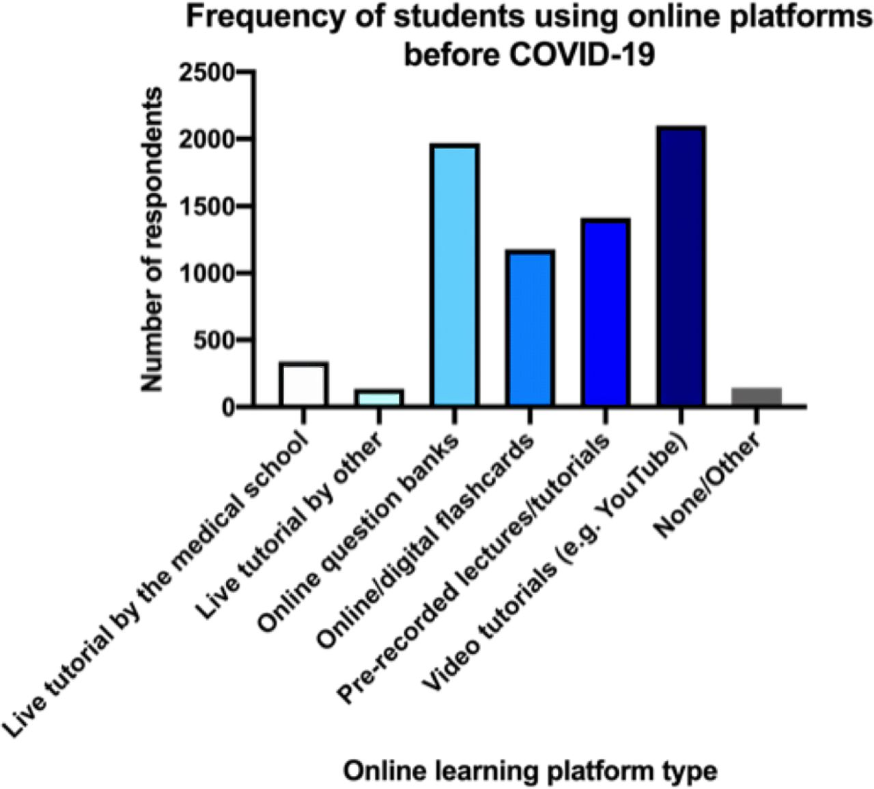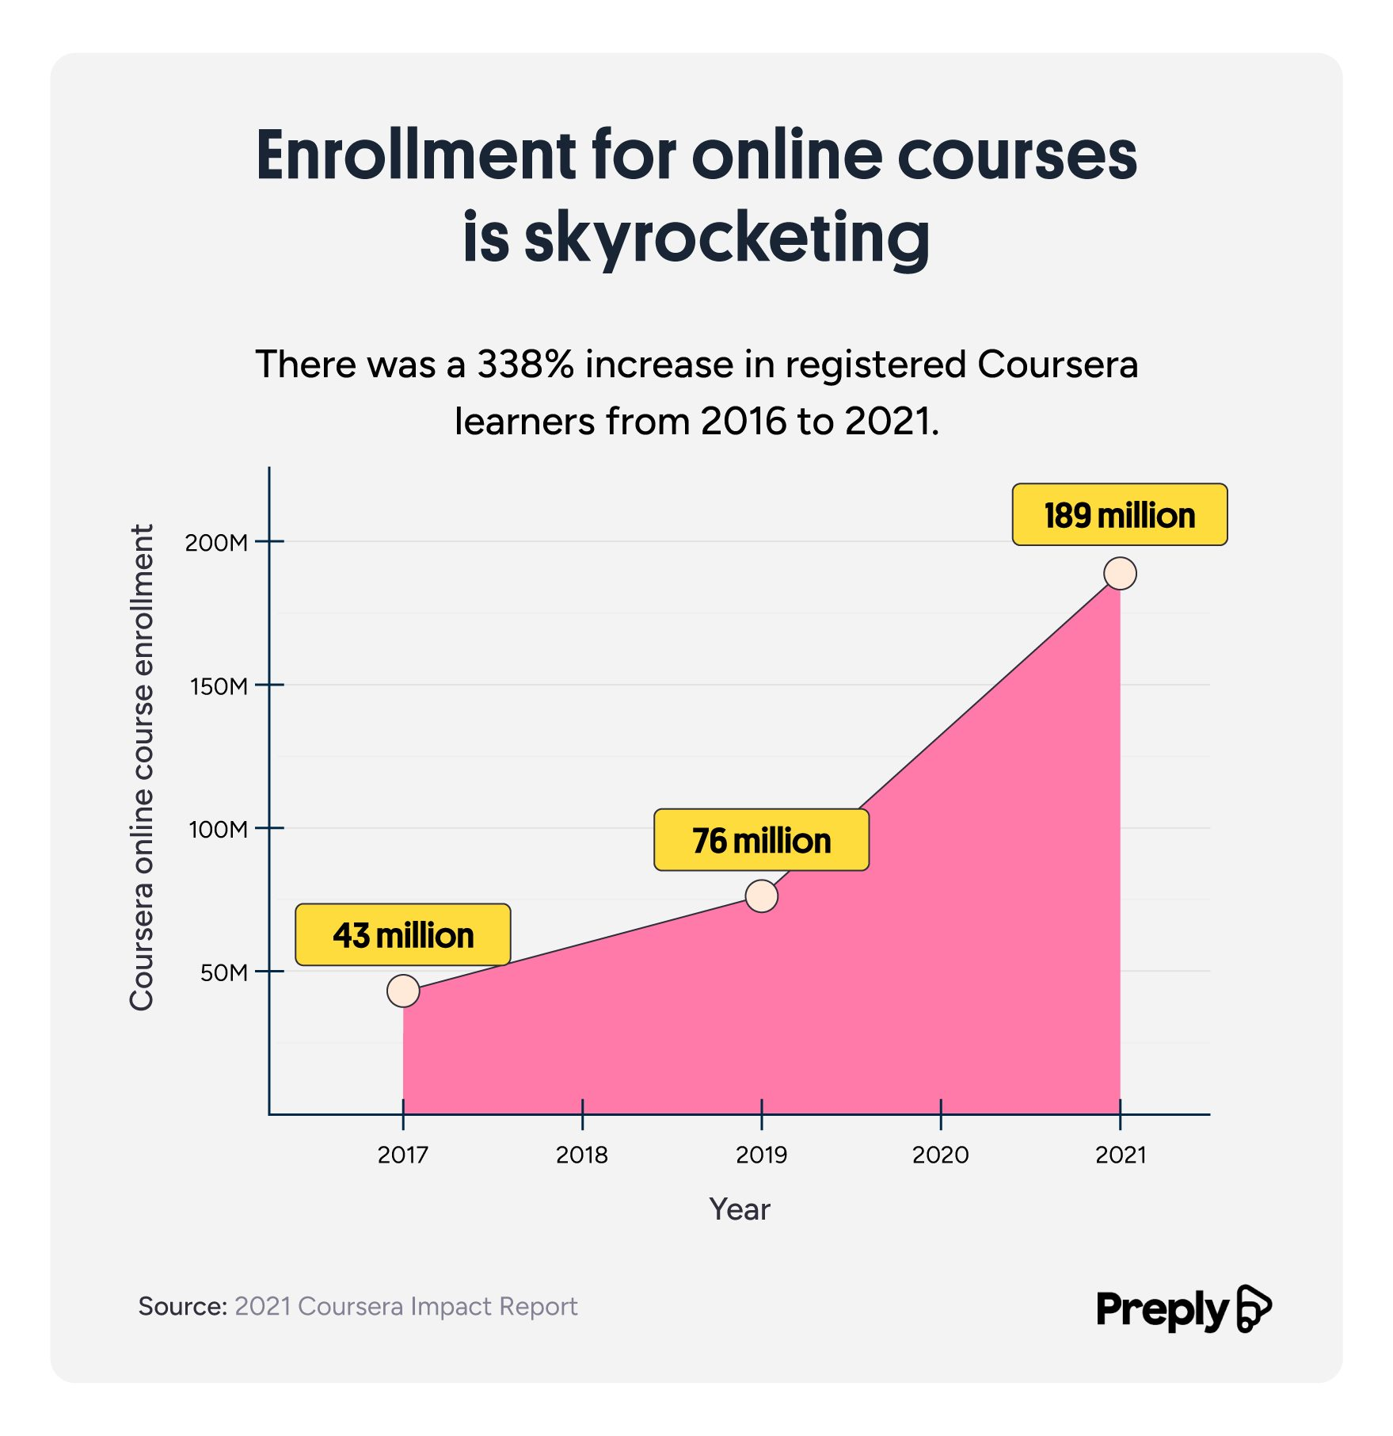

# **3. Proposed Solution and Application Details**

Our proposed solution is to develop a customized online teaching and learning platform tailored specifically for the students and faculty of ABC University. The platform will offer a seamless and engaging user experience for both students and educators, allowing for more effective teaching, learning, and collaboration.

## **Key Features of the Platform:**

* **Interactive Virtual Classrooms:**

The platform will offer virtual classrooms with interactive whiteboards, and an immersive learning environment and study space where students may collaborate with one another.

### **Customizable Curriculum Management:**

Teachers can easily create, organize, and deliver course materials, assignments, and assessments through the platform, encouraging organized learning and record keeping.

### **Integrated Communication Tools:**

Built-in communication tools such as discussion forums, messaging, and video conferencing will encourage cooperation and engagement between students and instructors.

### **Performance Tracking and Analytics:**

The platform will give insights into student engagement, performance, and progress, as well as insights into students' performances and tailor them accordingly.

### **Accessibility and User Friendly Interface:**

Accessibility features will be incorporated to ensure inclusivity, while the user interface will be intuitive and easy to navigate for all users.

Since the system will follow a modular approach, it will be easier to update or add new features to cater to new and unique demands. Furthermore, this allows seamless integration with other platforms from NeXus, allowing the system to possess the ability to readily merge with any platform.

# **4. Implementation of the System in the University**

To implement this system in the university, we propose a staged approach that includes the following steps:

### **Initial Planning and Requirements Gathering:**

Engaging with key stakeholders, including faculty members, students, and IT personnel, to gather requirements and ensure the system aligns with the university's specific needs.

### **Development and Testing:**

Collaborating with a team of experienced developers and testers to design and build the platform, assuring usability, scalability, user-friendly interface and security.

### **Pilot Testing and Feedback:**

Conducting a pilot test with a select group of faculty members and students to gather feedback, identify any issues, and make necessary improvements before a full-scale launch.

### **Training and Adoption:**

Organizing training sessions and workshops to familiarize faculty members and students with the platform's features and ensuring that they are seamlessly integrated into the teaching and learning process.

### **Continuous Support and Upgrades:**

Providing ongoing technical support and regular updates to enhance the platform's functionality in response to user feedback and emerging online education trends.

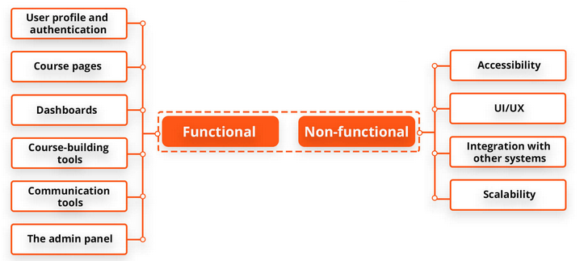

## **Benefits of the Proposed Platform:**

### **Enhanced Learning Experience:**

The platform will provide a more interactive and engaging learning experience for students, leading to improved retention and academic outcomes.

### **Streamlined Teaching Processes:**

Educators will benefit from streamlined curriculum management tools and enhanced communication, enabling them to focus more on teaching and less on administrative tasks.

### **Brand Enhancement:**

A custom online platform demonstrates our commitment to innovation and excellence in education, enhancing the university’s reputation and appeal to prospective students.

* Students have more freedom to work at their own pace, which improves their learning experience.
* Students learn better and feel more comfortable learning in an environment of their choosing. This isn’t always possible in a classroom but is one of the key advantages of online learning.

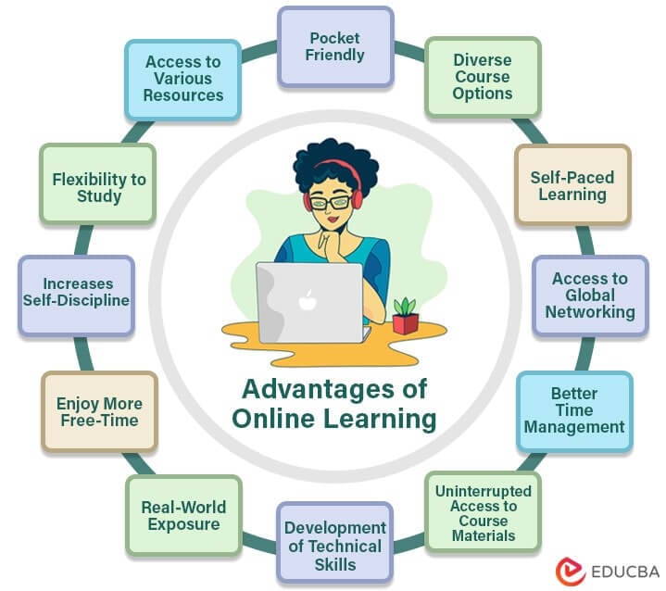

To summarize, the creation of an online teaching and learning platform for ABC University is an exciting potential to transform how we deliver education in the digital era. We are convinced that with the backing of university administration and our team's experience, we can develop a solution that not only satisfies the requirements of the students and instructors, but also establishes ABC University as a leader in online education.

Thank you for considering this suggestion. We are enthusiastic to continue the discussion and contribute to the project's success.

Sincerely,

Team NeXus.